CALL TO ORDER
  - The Board of Directors of the North Sonoma County Healthcare District met in person at 1381 University Avenue, Conf. Room 1, 2nd Floor, Healdsburg, CA and via Zoom Teleconference. Chair, Hector Galvan called the meeting to order at 4:03 PM.

  - Board Clerk, Juliana Dougan called the roll. The following Board members were present constituting a quorum:

Hector Galvan, Chair
Sue Campbell, Vice-Chair
David Anderson, MD – Director – Arrived at 4:07 pm
Erin Gore, Secretary
Brian Callahan, Treasurer

Also present: Richard Pio Roda, Esq., District Counsel

Guests:

Chair Galvan asked if there were any conflicts in regard to the Agenda. There were none. Chair Galvan asked if there were any public comments. There were none.

REGULAR BUSINESS

- Consent Calendar
- April 24, 2025 Regular Meeting Agenda
- March 27, 2025 Regular Meeting Minutes
- March 31, 2025 Financial Statements

Chair Galvan asked if there were any comments on the items on the Consent Calendar.

Chair Galvan called for a motion. Director Campbell MOVED to approve the Consent Calendar. Director Callahan SECONDED the motion. The roll call vote was as follows:

Vote: Anderson: Abs; Campbell: Y; Galvan: Y; Callahan: Y; Gore: Y. The motion was approved 4-0. 1-Absent

- Discussion / Informational / Possible Action: Finance Update
  - Pisenti & Brinker Engagement Letter
Director Callahan reported that $2.4M of parcel tax monies that was collected last year has been transferred to Providence. There will be another transfer in the fall for the 2nd installment.

The Audit is still underway. The debt service payment accounting is still being reviewed.

An engagement letter provided by the District’s current CPA bookkeeper has been received and provided in the Board packet. The fee rate increased by over 20% vs. last year. Discussion continued on the quality of work being provided, including errors recently uncovered. Director Gore shared her experience with Pisenti & Brinker through a separate business she is involved with. There has been an issue with errors and their responsiveness. The Board agreed that additional due diligence was needed prior to entering into a contract extension. Director Callahan will bring this issue before the Board again at the May Board meeting.

- Discussion / Informational / Action: Strategic Planning Discussion
Director Gore generated summaries of the five documents provided that reflected current need in the community based on listening sessions, the portrait of Sonoma, etc. There are a lot of similarities between the documents. Director Gore outlined the Strategic Planning exercise, in order to identify 2-3 Strategic Priorities. The first exercise was for the Board to determine what Themes stood out in the summaries. These Themes are:

- Mental/Behavioral Health
- Substance Abuse
- Housing and Unhoused People
- Access to Healthcare
- Access to Dental Care
- Aging Populations Needs
- Equity, Racism, Inclusion
- Community Centers
- Economic Inequity & Support Services
- Food Insecurities
- Convening People & Partners
- Communication Efforts
- Youth Mental Health
- Education
- Immigration/ICE
- Strengthening Partners Infrastructure

From these Themes, the Board was asked to consider ‘Rules’ that these Themes would need to fall under based on the Districts Mission and Vision. The Board agreed that these Rules are:

- Health Oriented/Driven
- District-Wide
- Approachable

The next steps in the exercise will be for each Board member to Combine the Themes. Each Board member would then share what Theme/Combination Resonates with them; what is most Urgent; and what is most Impactful.

The Strategic Priorities should be Health focused and Community focused.

Board members would then be asked to identify the top Priorities. These Priorities would be placed on a Grid – High Impact/Low Impact & High Feasibility/Low Feasibility. Feasibility was defined as Cost/Time commitment. Once the Priorities are placed on the Grid, each Board member will vote for their top three by vote. The top three receiving the most votes would become the Strategic Priorities.

Lastly the Board will be asked to name the overall Strategic Priorities. The hope is that these Strategic Priorities will drive the District’s agenda, grant giving request, Community impact, etc. Additionally, the Board will determine if there are any gaps or an opportunity to bridge between Themes.

Results of the exercise are summarized as follows:

Based on the Themes, listed below, each Board member was asked to Combine into priorities:

- Mental/Behavioral Health
- Substance Abuse
- Housing and Unhoused People
- Access to Healthcare
- Access to Dental Care
- Aging Populations Needs
- Equity, Racism, Inclusion
- Community Centers
- Economic Inequity & Support Services
- Food Insecurities
- Convening People & Partners
- Communication Efforts
- Youth Mental Health
- Education
- Immigration/ICE
- Strengthening Partners Infrastructure

Director Anderson: 1+9+13+15 ; 11+12+16 ; 4+5+6
Director Campbell: 1+13 ; 11+12+16 ; 7+9+15 ; 4+5
Director Gore: 11+16+4+12 ; 4+5+13+12+15 ; 12+13+14+2
Director Callahan: 11+12+16 ; transportation
Director Galvan: 1+13+4

The above symbols were plotted on the list of Themes below:

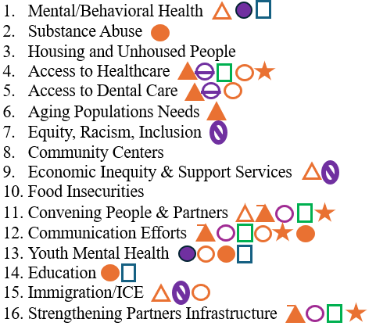

Based on the Themes and Combinations, the Board was asked what Resonated with them individually.

Director Anderson: Substance Abuse
Director Campbell: Underserved, risk of MediCal access, fear of going out, education
Director Gore; Mental Health, Substance Abuse, Access to Care, Connecting with people
Director Callahan; Community Center, Education, Support Services
Director Galvan: Youth mental health, education in-school

Based on the Themes and Combinations, the Board was asked what was an Urgent focus with them individually.

Director Anderson: Healthcare Access
Director Campbell: Healthcare Access, Aging, Mental Health
Director Gore; Immigration, Access to Care, Mental Health
Director Callahan; Immigration, Economic inequality
Director Galvan: Youth mental health

Based on the Themes and Combinations, the Board was asked what was most Impactful for them individually.

Director Anderson: Substance Abnse
Director Campbell: Underserved population due to Immigration or financial
Director Gore: Convening people, Mental Health, Education
Director Callahan; Identify opportunities – overarching leadership, identify gaps
Director Galvan: Community Center, Immigration/ICE - Education

The Board next narrowed and combined the priorities into seven. These were:

- Community leadership – Convening, Communication, Strengthening
- Youth Mental Health
- Access to Healthcare
- Substance Abuse
- Immigration/Underserved Communities
- Aging
- Community Center

The next step in the process involved plotting the seven priorities on a High Impact/Low Impact & High Feasibility/Low Feasibility grid. Low feasibility was described as high cost, long timeline and high effort. High feasibility was described as low cost, fast timeline, low effort. After considerable discussion, each Board member agreed with the placement shown below:

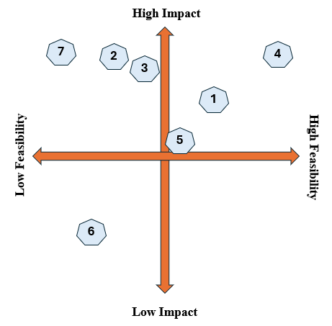

The Board was asked to place three votes next to the priority(ies) that they felt strongest about. The results of the weighting is as follows:

- Community leadership – Convening, Communication, Strengthening (n=5)*
- Youth Mental Health (n=2)
- Access to Healthcare (n=3)*
- Substance Abuse (n=6)*
- Immigration/Underserved Communities (n=1)
- Aging (n=1)
- Community Center (n=2)

*These three top priorities will be the structure of the 2025 Strategic Plan.

The Board will revisit the results during the May 29, 2025 Board Meeting and confirm the Strategic Plan and move to adopt.

- Discussion / Informational: Grant Committee Update
Director Callahan reported that the Board received a thank you letter from the Foundation for the annual distribution of $100K based on the MOU. Directors Gore, Campbell and Callahan attended the Healdsburg City Council meeting on Monday. An additional $30K was granted from Sonoma County to be applied to the CalAim activities including an additional $70K was granted as well from the Sonoma County Community Foundation for CalAim. They are hoping to receive another $100K.

- Discussion / Informational: Hospital Matters
- Community Board Meetings
The Community Board meeting this month focused on credentialing, so there was not much more to report.

- Quality Committee
Ms. Susan Schmidt gave a presentation at the Quality Committee meeting, and Director Campbell asked if she could share it with the Board. She will share the presentation at a future Board meeting. It was reported that Healdsburg Hospital has the lowest rated facility sepsis mortality rate in the Providence south division which includes California.

- Community Benefit Committee
The Community Benefit Committee met on Monday. Ms. Michelle Oxford is working to review and revise how the granting pertaining to Healdsburg is discussed and awarded. Director Gore will be brought in to review the funnel of grants. To date, the grants applications are closed. Director Gore will play a role in this restructuring.

- Discussion / Possible Action: Regarding District Housekeeping
- Future Agenda Items
3D Mammography Project, including a potential expert speaker – May
Healdsburg Hospital Quarterly Report and Capital Investment Report – May
Botanical Bus – May
Strategic Plan revisit and naming – May
Redistricting discussion - June
Add Philanthropy Board representation on each agenda – Director Anderson

- Legal Report
Director Gore acknowledged the redistricting summary that Mr. Pio Roda provided to the Board and whether this should be discussed in May or delayed until June when there is more time. The Board has adopted a resolution of intent that it was going in the direction of redistricting. Mr. Pio Roda did confirm that the District would be at risk by not taking this action. The potential of a lawsuit remains. If the Board agrees to move forward, with regard to legal fees, the fees would be capped at $30K. Mr. Pio Roda revised the timeline the Board would undertake to support four public hearings, etc.

It was agreed to revisit this discussion at the June 26, 2025 meeting.

- Consideration of Materials Disseminated by Board Members.
Director Gore shared that she attended the Cannabis Ad Hoc Cloverdale meeting, and the City of Cloverdale has selected tax monies from the Cannabis business to fund health education, including drug education, in the schools. Director Gore suggested that the Board recommend certain organizations that do this type of education utilizing these funds in the form of a memo from the District Board.

Chair Galvan stated that he will need to recuse himself due to conflict of interest pertaining to many positions he holds in Cloverdale. Chair Galvan will discuss this issue with Mr. Pio Roda offline. Mr. Pio Roda will provide legal guidance to Director Gore regarding the memo.

Director Anderson shared that through Alliance Medical Group, 2,500 boxes of Narcan were received and are in the process of increasing distribution. Distribution does not only focus on the underserved, but all populations. The Cloverdale mayor will be attending the next Harm Reduction Task Force. There will also be a distribution event on Friday, April 30, at St. John’s church at 8:30 am. Director Anderson invited the Board to attend if they are available.

- Chair Galvan adjourned the meeting at 6:04 PM.

