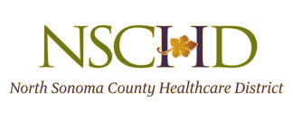

NOTICE OF CANCELLATION

The North Sonoma County Healthcare District Special Meeting scheduled for
Thursday, July 15, 2021 has been cancelled due to lack of quorum.

The Regular Monthly July Board Meeting is scheduled for
Thursday, July 29. 2021

